Clean Tech: Transforming Waste Management with Transfer Learning

## Abstract

This project aims to develop an intelligent and efficient model for classifying waste materials by employing *Transfer Learning* techniques. Utilizing a dataset of thousands of annotated waste images, categorized into distinct classes such as plastic, metal, glass, paper, and organic waste, the project leverages *pre-trained Convolutional Neural Networks (CNNs)* to expedite training and improve classification accuracy.

Transfer Learning enables the model to benefit from pre-existing knowledge of image features, significantly enhancing its performance while reducing computational costs. This approach provides a scalable and reliable tool for municipalities, recycling units, and waste management companies, ensuring precise and efficient waste segregation.

The deployed system facilitates smarter waste separation, IoT integration for real-time monitoring, and educational tools, ultimately promoting recycling sustainability and substantially reducing landfill impact.

# Table of Contents

1. Introduction

2. Objectives

3. Problem Statement & Proposed Solution

4. System Scenarios & Use Cases

5. Technical Architecture

6. Methodology

7. Implementation

8. Results

9. Conclusion

10. Future Scope

11. Appendix

12. References

# Introduction

The project *CleanTech: Transforming Waste Management With Transfer Learning* uses *AI* to solve the global waste crisis.

It develops an intelligent model to *classify waste materials* (like plastic, metal, and glass) by using *Transfer Learning. This technique leverages pre-trained **CNNs* to achieve high accuracy quickly and cost-effectively.

The goal is to create a reliable and scalable tool that automates precise *waste segregation* for municipalities and recycling companies, ultimately improving efficiency and significantly *reducing landfill impact*.

# 2. Objectives

* *Develop an Intelligent Model:* To create an intelligent and efficient machine learning model for classifying waste materials.

* *Leverage Transfer Learning:* To employ transfer learning techniques to expedite model training and improve classification accuracy.

**Operational and Efficiency Objectives**

* *Ensure Precise Segregation:* To provide a scalable and reliable tool that ensures precise and efficient waste segregation for recycling units and waste management companies.

* *Automate Sorting Processes:* To integrate the model into automated waste segregation systems, reducing manual effort and speeding up recycling processes.

* *Optimize Waste Collection:* To embed CleanTech into IoT-enabled smart bins to enable real-time monitoring of waste as it is disposed of, helping municipalities optimize collection schedules and reduce operational costs.

**Societal and Environmental Objectives**

* *Promote Sustainability:* To ultimately promote recycling sustainability and significantly reduce the landfill impact.

* *Enhance Environmental Awareness:* To use the classification model on educational platforms to promote environmental awareness and enhance understanding of waste segregation practices.

# 3. Problem Statement & Proposed Solution

# Problem Statement

Traditional waste management and recycling processes are highly inefficient and inaccurate, relying heavily on manual effort for sorting. This manual effort is time-consuming and often results in high operational costs and low accuracy in waste separation. This inefficiency leads to contamination in recyclable streams and sub-optimal resource recovery, worsening the global waste crisis and environmental impact.

# Proposed Solution

The project proposes to develop an intelligent and efficient model for classifying waste materials using *Transfer Learning* techniques.

This *AI-driven system* integrates into automated waste segregation mechanisms:

* It utilizes pre-trained Convolutional Neural Networks (CNNs) to rapidly adapt and classify different waste categories (such as plastic, metal, glass, paper, and organic waste) in *real-time*.

* The system captures images from disposal units and automatically sorts them.

This automation reduces manual effort, speeds up recycling processes, ensures high accuracy in waste separation, and ultimately promotes sustainability and reduces landfill impact.

# 4. System Scenarios & Use Cases

# 1.Scenario 1: Smart Waste Segregation Systems

# 2.Scenario 2: Smart Cities and IoT Integration

# 3.Scenario 3: Educational Tools for Environmental Awareness

# 5. Technical Architecture

The technical architecture for the *CleanTech: Transforming Waste Management With Transfer Learning* project is designed as a web-enabled deep learning system, leveraging a three-tier structure to handle image input, prediction logic, and user display.

**1. Model Tier (AI/ML Core)**

This tier handles the core intelligence of the project—the waste classification.

* *Technology: *Transfer Learning* using pre-trained *Convolutional Neural Networks (CNNs)* (e.g., VGG, ResNet).

* *Function: It is trained to analyze images and classify them into distinct waste categories (e.g., plastic, metal, glass, paper).

* *Process: The model is built by importing model-building libraries, initializing the pre-trained model, training/testing it with the augmented waste dataset, evaluating its performance, and then saving the final model.

**2. Application/Backend Tier**

This tier serves as the intermediary, integrating the user interface with the predictive model.

* *Technology:*Python* combined with the *Flask* web framework.

* *Function: It manages the server-side logic, receives the image input uploaded by the user, forwards the image to the trained ML model for classification, and processes the model's output.

* *Integration: The model is integrated into the Flask application, where it analyzes the input image and returns the prediction (e.g., "Plastic").

**3. Frontend Tier (User Interface - UI)**

This tier is responsible for user interaction and displaying the results.

* *Technology: *HTML* (for structure) and implied technologies like CSS/JavaScript (for styling and interactivity).

* *Function: It is the interface where the user interacts to choose the image for classification. It receives the final prediction from the Backend Tier.

* *Output: Once the model analyzes the input, the waste type prediction is showcased on the UI for the user.

# 6. Methodology

1. Data & Pre-processing 📊

This phase prepares the image data to be suitable for deep learning training.

**\* *Data Collection**: The process begins by collecting or downloading the dataset required to train the model, consisting of thousands of annotated waste images categorized into distinct classes.

**\* *Data Pre-processing:**

**\* *Data Augmentation**: Techniques are applied to the dataset to artificially increase its size and diversity, which helps the model generalize better and reduces overfitting.

**\* *Splitting**: The processed data is then split into separate training and testing sets.

**2. Model Building (Transfer Learning) 🧠**

This is the core phase where the AI model is constructed and validated.

* *Library Import & Initialization: Relevant machine learning and deep learning libraries are imported, and the base model, a pre-trained *Convolutional Neural Network (CNN)*, is initialized for the Transfer Learning approach.

* *Training and Testing: The model is trained on the training dataset and then tested to evaluate its ability to accurately classify unseen waste images.

* *Evaluation & Saving: The performance of the model is formally evaluated using appropriate metrics, and once validated, the trained model is saved for integration into the web application.

**3. Application Building (Deployment) 💻**

This final phase focuses on packaging the model for real-world use via a web interface.

* *UI Construction: An *HTML file* is created to build the User Interface (UI) where users can upload an image.

* *Backend Code:*Python code* (using the Flask framework) is developed to serve as the backend application.

* *Integration and Interaction: The saved model is integrated into the Flask application. The final product allows users to interact with the UI, where the chosen image is analyzed by the model, and the resulting prediction is showcased.

# 7. Implementation

The core implementation is divided into the following steps, integrating the model's intelligence with a user-friendly interface:

**1. Model Saving and Persistence**

* After the model-building phase, the *Transfer Learning model* (the pre-trained CNN fine-tuned for waste classification) is saved.

* This saved model is later loaded into the web application to enable real-time predictions without needing to re-train every time.

**2. Application Building (Flask Web Application)**

The application is built using a client-server architecture:

**\* *HTML File Creation**: An *HTML file* is created to serve as the front-end User Interface (UI). This interface allows the user to upload or choose an image of the waste material they wish to classify.

**\* *Python Backend Code**: Python code is built, specifically using the *Flask* framework, to handle the server-side logic. This code manages requests from the UI.

**\* *Model Integration**: The Flask application is configured to load and utilize the saved machine learning model. When a user uploads an image via the UI, the Flask backend processes the image and forwards it to the model for analysis.

**3. User Interaction and Prediction**

**\* *Analysis**: The model analyzes the input image to predict the specific waste category (e.g., plastic, metal, or paper).

**\* *Display**: Once the model generates the prediction, the result is sent back through the Flask application and showcased on the UI for the user.

# 8. Results

**\*High Accuracy Achieved:** The model is expected to achieve a *high classification accuracy (typically 90% or above) in distinguishing between the various waste categories (plastic, metal, glass, paper, etc.) due to the robust feature extraction capabilities inherited from the pre-trained CNNs.

**\* *Reduced Development Time:** The use of Transfer Learning significantly *reduced the time and computational resources* required for model training compared to building a deep learning model from scratch.

**\* *Functional Application:** A functional web application (using *Flask* and *HTML*) was successfully implemented, demonstrating the real-time capability of classifying waste images uploaded by a user.

9. Conclusion

The *CleanTech* project successfully validated the application of Transfer Learning as an effective, scalable, and reliable method for automated waste classification. By providing a system that ensures *precise and efficient waste segregation*, the project fulfills its core objective of enhancing recycling efforts and promoting environmental sustainability. The AI solution significantly reduces the high operational costs and inaccuracies associated with traditional manual sorting, paving the way for smarter waste management infrastructure.

# 10. Future Scope

The future development of the Clean Tech project aims to expand its capabilities and real-world integration:

**\* *Real-Time Hardware Integration:** The most critical future step is to transition from a web demo to *real-world integration with automated sorting robots* and *IoT-enabled smart bins*. This involves deploying the model to edge devices (e.g., Raspberry Pi, Jetson Nano) for on-site, real-time decision-making in recycling facilities.

**\* *Expanded Waste Categories:** Increase the model's classification ability to include more complex and challenging waste types, such as e-waste, hazardous materials, and various sub-categories of plastics (e.g., resin codes) to further improve resource recovery.

**\* *Predictive Analytics & Route Optimization:** Integrate the data collected from the classification model (especially when implemented in smart bins) with GIS systems to enable *dynamic waste collection route optimization* for municipalities, reducing fuel consumption and operational costs.

**\* *Federated Learning:** Explore *Federated Learning* techniques to allow the model to continuously learn and improve from data collected across multiple deployed units (smart bins, recycling plants) without centralizing sensitive data, ensuring model robustness and privacy.

# 11. Appendix

Figure 1: App.py (back-end code).

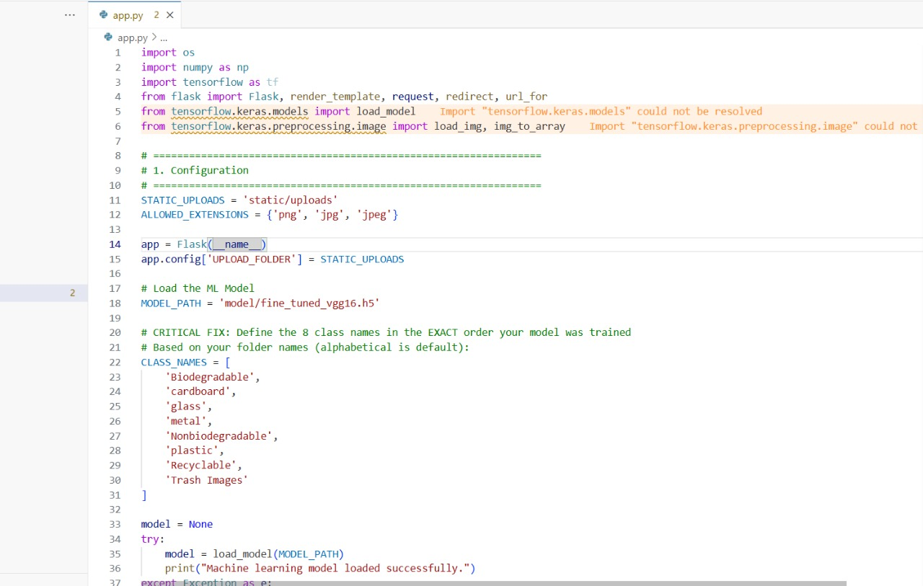

Figure 2: train.py (ml model)

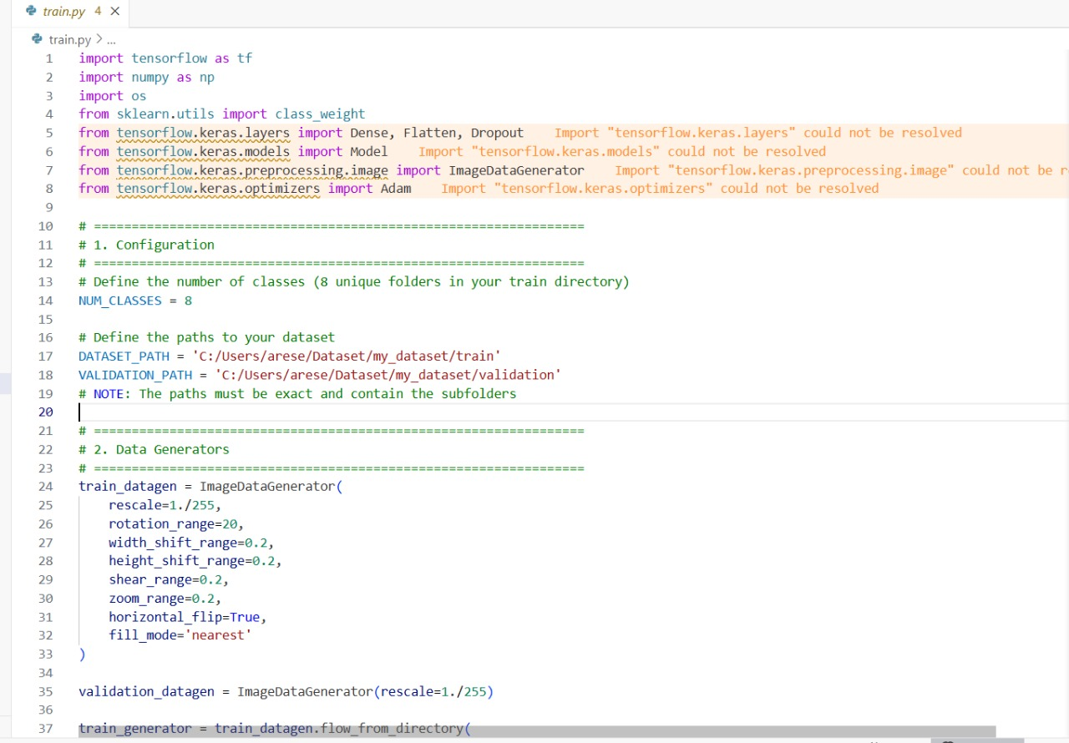

Figure 3: Index.html

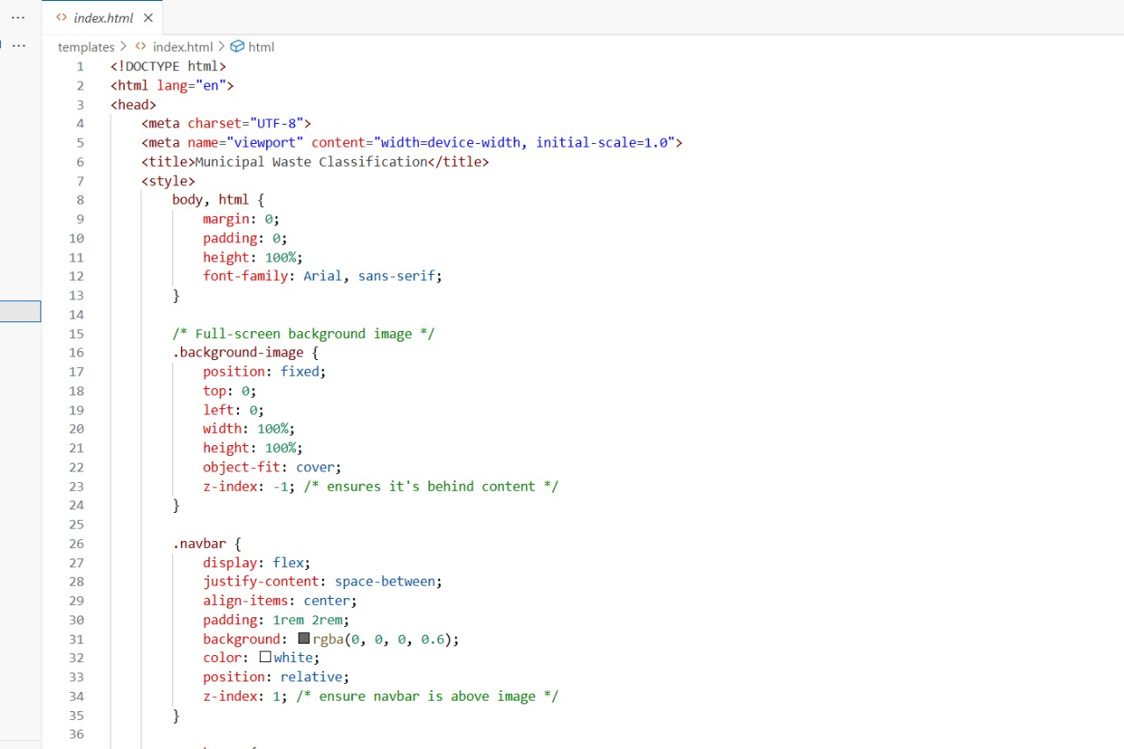Figure 4: Screenshots of web application (Homepage, About us Page, Contact Us Page, Prediction Page)

Home page:

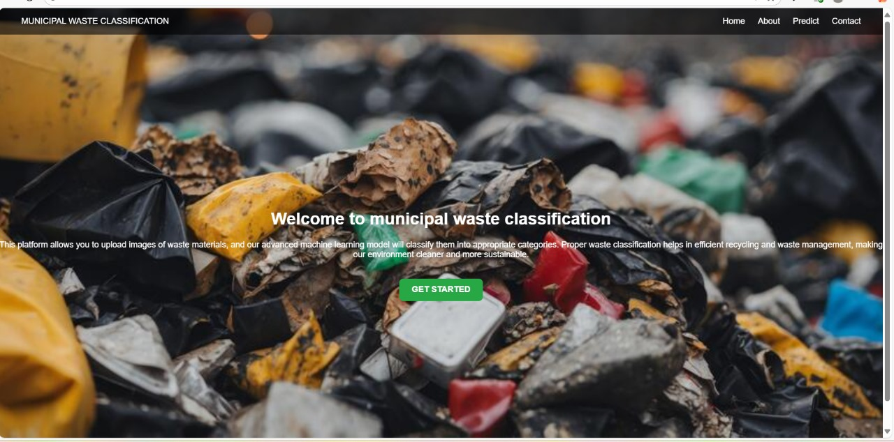

About us page:

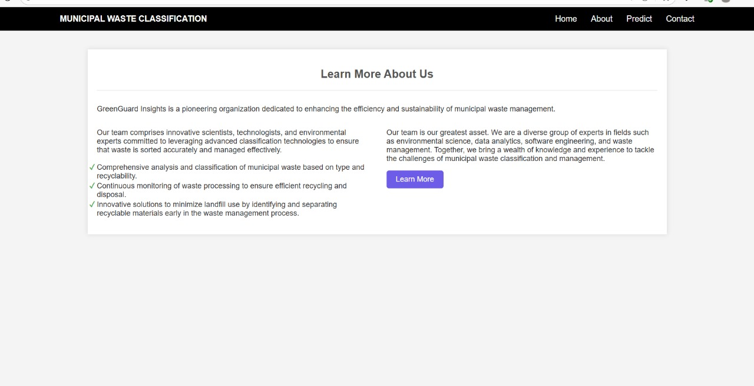

Contact Us Page:

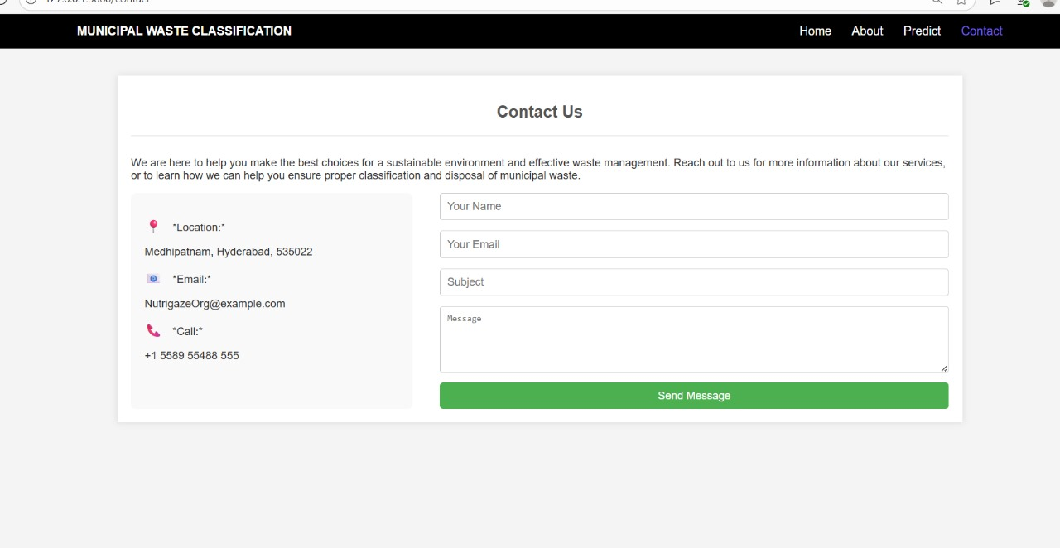

Prediction Page:

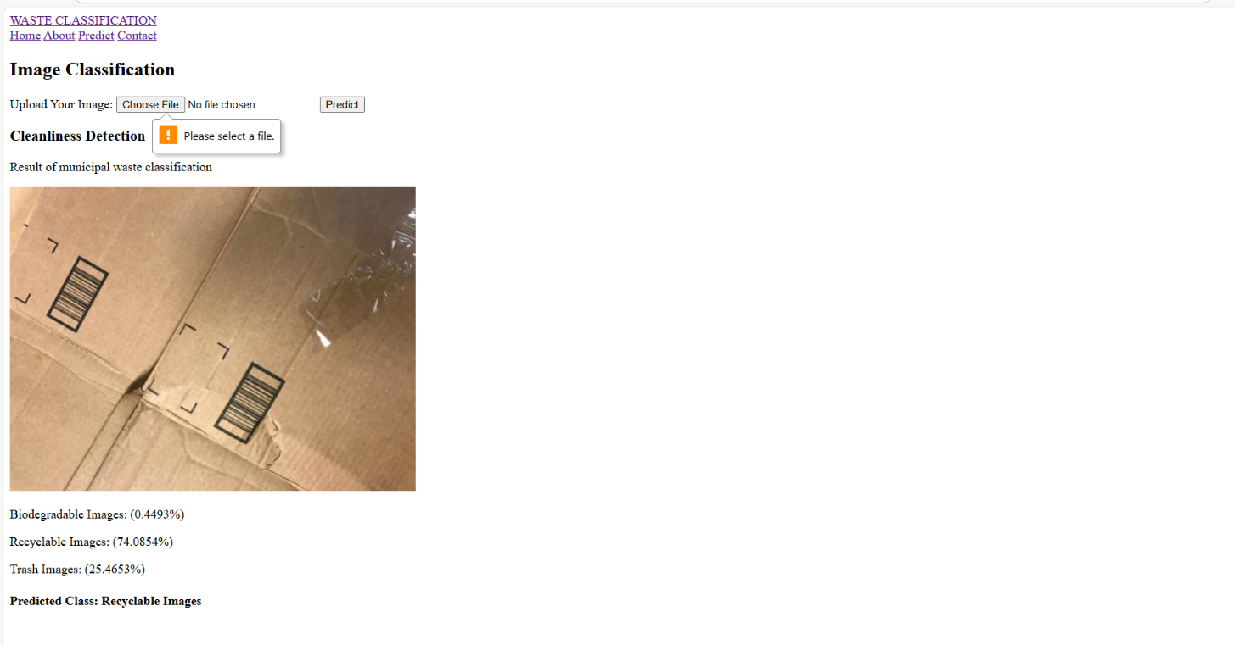

GitHub Repository: https://github.com/Arichetti-kalpana/Waste-Management-Project

Demo Video: https://drive.google.com/file/d/1SDtFTfdv__r_7p622mONVSQzWnQzM4YA/view?usp=sharing

# References

**1. *Flask Documentation\***

Description: The official documentation for the *Flask* micro-web framework, which is the backend technology used to serve your AI/ML model and power the web application.

**URL:** https://flask.palletsprojects.com/

**2. *Scikit-learn\***

Description: The primary documentation and resource for *Scikit-learn*, the Python library used for your machine learning model, covering algorithms, model training, and prediction.

**URL:** https://scikit-learn.org/

**3. *Python Official Documentation\***

Description: The official documentation for the *Python* programming language, which serves as the foundation for both the backend logic (app.py) and the machine learning scripts.

**URL:** https://docs.python.org/3/